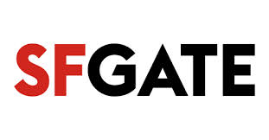

Sausalito Art Festival is big business and big entertainment
By Aidin Vaziri
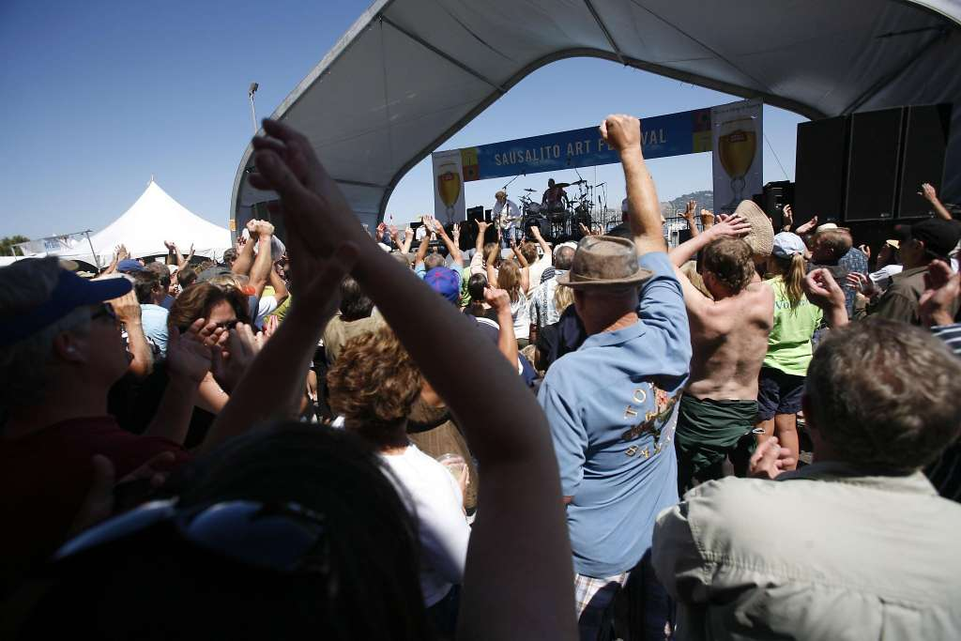

Published 2:58 pm, Monday, August 29, 2016

Photo: Publicity By Design
IMAGE 1 OF 3
Rod Argent and Colin Blunstone of the Zombies will play.
Don’t let the idyllic waterfront views, flowing spirits or throwback tunes fool you — the 64th Sausalito Art Festival is serious business. One of the longest-running and most well-oiled events of its type, the annual three-day open-air marketplace draws artists from across the country to Marinship Park.
This year’s list of exhibitors includes names like Nicky Statius, Kathleen Lipinski, Richard Hall, Dolan Geiman and many others, with work on display for art aficionados and collectors from around the world. Of course, for those who just want an excuse to mingle around white tents and take in the scene, there’s that too.
The entertainment lineup features Monophonics, Squirrel Nut Zippers, the Unauthorized Rolling Stones, Todd Rundgren and the Zombies.
— Aidin Vaziri
Sausalito Art Festival: 10 a.m. Saturday-Monday, Sept. 3-5. $20-$100. Marinship Park, Sausalito.http://sausalitoartfestival.org

http://www.sfgate.com/entertainment/article/Sausalito-Art-Festival-is-big-business-and-big-9191421.php#photo-10825346

