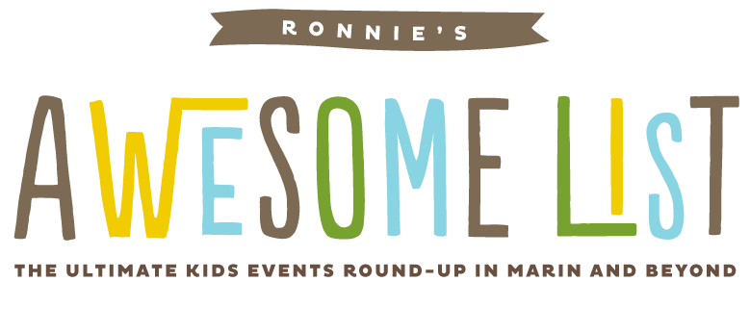

How To Make The Most Of The Sausalito Art Festival
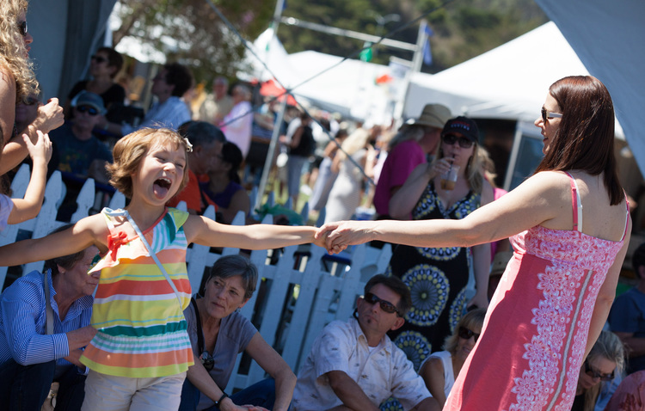
Photos by: Amy Hart
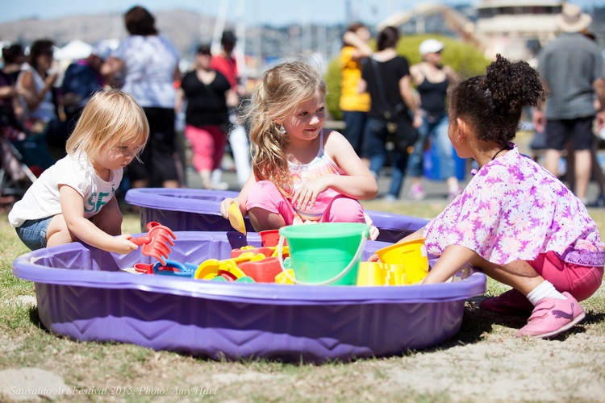

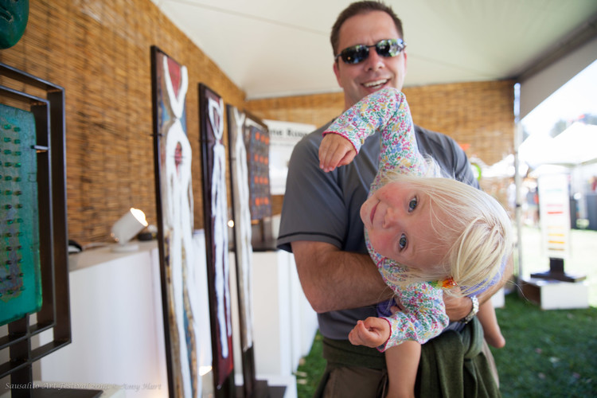
Get ready for three full days of spectacular artwork, headline music acts, gourmet food, children's entertainment at The Sausalito Art Festival. The place to be over Labor Day Weekend. More than 260 award-winning artists from around the country will line the waterfront village of Sausalito with world class art, celebrated entertainment lineup, special exhibitions and a cornucopia of gourmet food, wine, beer and specialty beverages.

When: September 3 – 5 (Labor Day Weekend)
Where: Marinship Park at end of Marinship Way, Sausalito
Tickets: VIP ticket - $100/day includes special entrance at festival, two complimentary drink tickets and VIP seating at the main tent; General Admission - $25; Seniors (62 & over) - $20
Children (6-12) - $5; Children under 12 – FREE (when accompanied by an adult). Tickets are also sold onsite at the Festival. Tickets available through Eventbrite.
For full festival information visit www.sausalitoartfestival.org

2016 Music & Children's Entertainment Lineup:

SATURDAY, SEPTEMBER 3RD
Main Stage
12:00-1:00pm: Charlie Musselwhite (blues)
1:30-2:30pm: Blind Boys of Alabama (gospel)
3:00-4:30pm: Squirrel Nut Zippers (jazz/swing)
5:00-6:00pm: Monophonics (R&B/soul)
Artist Stage
11:00-12:30pm: Vardo Gypsy Jazz (flamenco/jazz)
1:00-3:00pm: Marie-Louise and The Humdingers (jazz/blues)
3:30-5:30pm: One Grass Two Grass (bluegrass)
Children's Area
12:00-12:30pm: Magic Circus Family Show
1:00-12:30pm: Mark & Dre Comedy Show
2:30-3:00pm: Tim Cain
3:30-4:00pm: Magic Circus Family Show
4:30-5:00pm: Mark & Dre Comedy Show

SUNDAY, SEPTEMBER 4TH
12:00-1:00pm: Super Diamond (Neil Diamond tribute)
1:30-2:30pm: Zepparella (All female Led Zeppelin tribute)
3:00-4:00pm: Unauthorized Rolling Stones (Rolling Stones tribute)
4:30-6:00pm: Stayin' Alive - A Bee Gee's Tribute (Bee Gee’s tribute)
Artist Stage
11:00-12:30pm: Romanza (classical)
1:00-3:00pm: Deborah Winters Group (jazz/standards)
3:30-5:30pm: Beyond Standard Jazz (jazz)
Children's Area
12:00-12:30pm: Mark & Dre Comedy Show
1:00-12:30pm: Magic Circus Family Show
2:30-3:00pm: Tim Cain
3:30-4:00pm: Mark & Dre Comedy Show
4:30-5:00pm: Magic Circus Family Show

MONDAY SEPTEMBER 5TH
Main Stage
12:00-1:15pm: Edgar Winter (blues/rock)
2:00-3:15pm: Todd Rundgren (rock/pop)
3:45-5:00pm: The Zombies (rock)
Artist Stage
11:00-12:30pm: Bob Culbertson (jazz/world)
1:00-2:30pm: Carbe and Durand (jazz/flamenco)
3:00-5:00pm: The Dixie Giants (Dixieland jazz)
Children's Area
12:00-12:30pm: Tim Cain
1:00-12:30pm: Mark & Dre Comedy Show
2:30-3:00pm: Magic Circus Family Show
3:30-4:00pm: Mark & Dre Comedy Show
4:30-5:00pm: Magic Circus Family Show
Clo-the-Cow will appear on Saturday and Sunday 12noon-2pm
Facepainter will be on site 11am-5pm each day sponsored by the Bay Model Alliance.
August 22, 2016/ Comment

http://www.ronniesawesomelist.com/blog/sausalitoartfestival2016

